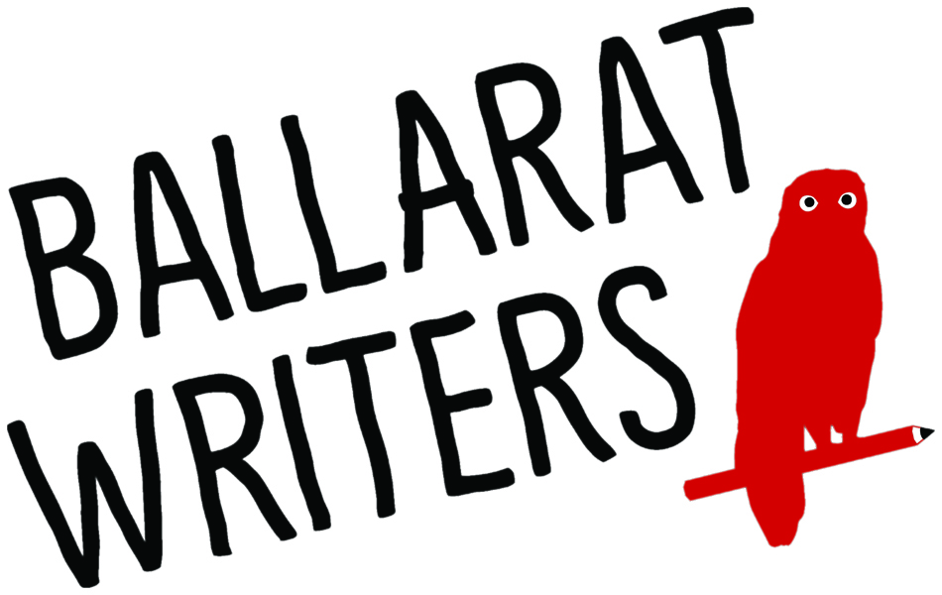

NOMINATION FORM

FOR THE ELECTION OF COMMITTEE OF MANAGEMENT

AT THE 2020 ANNUAL GENERAL MEETING

I … ……………………………………………………………
(Name)

of………………………………………………………………
(Address)

being a financial member of Ballarat Writers Incorporated, nominate myself for the following Office Bearer position (please circle)

Chairperson
Treasurer & Membership Coordinator
Secretary/Public Officer
Competitions Coordinator Publicity & Media Coordinator
General Committee Member
NB: The position of Treasurer requires skills and experience in finance and/or bookkeeping.

The Annual General Meeting will be held at 7pm on February 12, 2020 at Bunch of Grapes Hotel, 401 Pleasant Street, Ballarat.

Signature of nominator …………………………………………….....

Return the completed nomination form via email to Rebecca Fletcher at chairperson@ballaratwriters.com by Wednesday February 5, 2020. Late nominations will not be accepted.

If you are unable to provide a scan of your signature, please email the form without a signature. You will be required to produce the original signed copy at the AGM for the nomination to be eligible.

