Anthology 2018
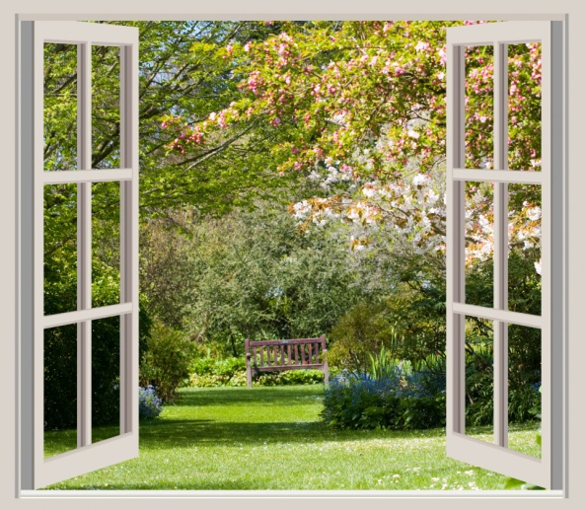

A Window of Opportunity
- All Professional Writing students (past and present) are invited to submit a story/poem to Anthology 2018.
- The theme for this year’s Anthology is A Window of Opportunity.
GENERAL GUIDELINES:
- All genres are acceptable including poetry.
- The word count for this submission is 3000 words.
- Manuscripts must be original works.
- Individuals are allowed to submit a maximum of two stories and one piece of poetry.
- Creative non-fiction entries must include bibliographical information about any sources used in the writing of this piece. Direct quotes or paraphrases must be acknowledged, and should be short to avoid any copyright complications. MLA reference format is preferred−see this website for referencing instructions:
http://federation.edu.au/__data/assets/pdf _file/0015/164121/FedUni-General-Guide-to-Referencing-2014.pdf
FORMATTING GUIDELINES:
- Entries must in English, double-spaced, using Times New Roman in size 12.
- All submissions must be in electronic format. No hard copies will be accepted.
- Save your story as a PDF file or Microsoft Word document, and then attach it to your email. In the subject matter put ‘Anthology 2018’.
- Include a title page with the following details: your full name, email address, the title of your story, and the final word count.
- Include your entry’s title and page numbers as a header on each page. Your name should only be on the cover, for anonymity in the selection process
SUBMISSION GUIDELINES;
- Opening date for submissions is February 12, 2018.
- Entries to be emailed to the email address below before the closing date at midnight on Friday June 15, 2018.
- One document and one cover page per submission.
- All entrants will receive notification that their submission has been received.
- Entrants will be notified whether their submission is successful or unsuccessful by July 31, 2018 via email.
- Email all submissions to debbiegoldie@live.com

