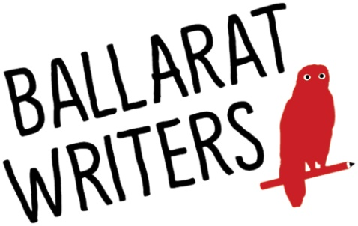
SOUTHERN CROSS LITERARY COMPETITION
ENTRY FORM
Closing date: 16 October 2017

Please print clearly. An entry form is required for each story submitted.
Author’s name: ……………………………………………..…………………………
Address: ……………………...………………………………………………………..
Postcode: …………………….. Phone: ………………..…………………………
Email Address: …………………………………………………………………………..…
Title of Story: ……………………………………………………………………..………
First Line of Story:
……………………………………………………………………..……………………………
Permission to Publish:
I, …………………………………………….., give permission for the above work to be published:
In PART………………………….. □ YES □NO
In FULL……………………………...□ YES □NO
On Ballarat Writers website www.ballaratwriters.com □YES □NO
In any Ballarat Writers publications □YES □NO

Declaration by Author:
I agree to the Competition Guidelines, and declare that the work submitted in my name is my own original work and has not been copied, in part or in full, from any other source.
Author’s Signature: ………………………………………………..……. Date: ………….…

ADDRESSES FOR SUBMISSION:
EMAIL:
competitions@ballaratwriters.com
Subject: ‘SCLC Entry’
Please send entry form and story as SEPARATE ATTACHMENTS (not in the body of the email). Accepted Formats: .doc, .docx, .pdf
POST: Southern Cross Literary Competition
PO Box 2738, Bakery Hill, Victoria 3354, AUSTRALIA

